EXPLORATION OF THE FRAGARIA VIRGINIANA FROM THE ROSACEAE FAMILY
Rosaceae is found throughout the world except in Antarctica, but it has its greatest diversity in the north temperate regions. Plant family members are trees, shrubs and herbs that vary in size. Rosaceae family members, in general, have pinnate¹ leaves with serrated edges that are arranged spirally on branches. The flowers have five sepals², five petals and several stamens that are arranged in many ways. Rosaceae plant family members also have fruits, such as apricots, almonds, cherries, peaches, blackberries, raspberries, apples, pears and strawberries. Fruits may be soft and fleshy, such as drupes, or hard pseudo carps³ such as hips. Fruits are usually purple, red or yellow. The Rosaceae family is large, diverse and contains several thousand species with varying uses.

Fragaria virginiana
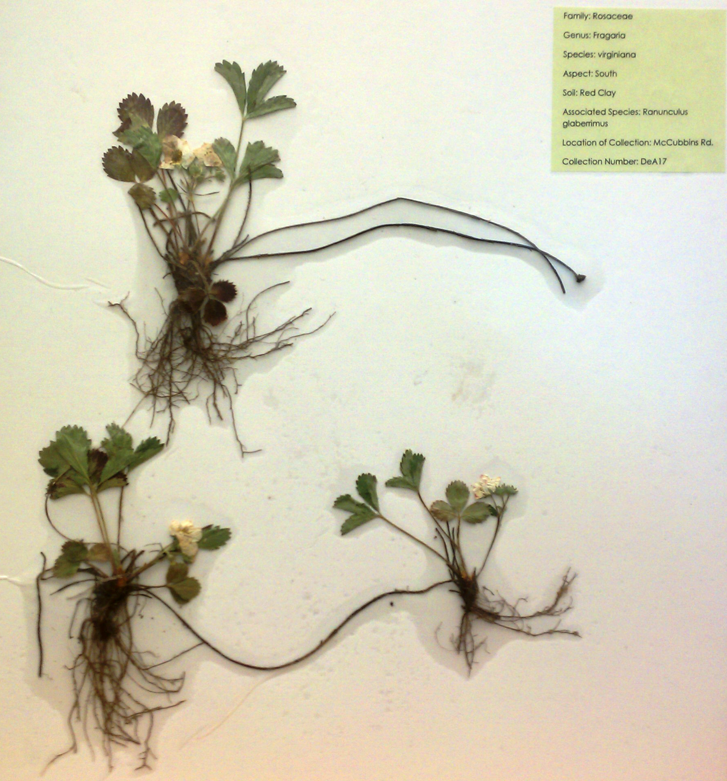
Fragaria virginiana by K.D.

Taxonomy of Fragaria virginiana
Kingdom | Infrakingdom | Subdivision | Class | Order
Plantae | Streptophyta | Spermatophytina | Magnoliopsida | Rosales
Subkingdom | Division | Infradivision | Superorder | Family
Viridaeplantae | Tracheophyta | Angiospermae | Rosanae | Rosaceae

Hinted by the infradivision, Fragaria virginiana is an angiosperm, or a flowering plant. Flowers include male and female reproductive parts, such as pistils, stamens, and ovaries. Compared to pterophyta and gymnosperm, angiosperm are the most complex, while pterophyta are the least so; dating back to the Devonian age.
Reproduction of Fragaria virginiana
While actively growing, Wild Strawberry produces long hairy runners up to six decimeters long, which re-root to form plantlets⁴. Each flower is about two centimeters across and consists of five white petals. Toward the center, there are about twenty-five yellow stamens surrounding a small blunt cone, and a stigma, style, and ovary. There is no noticeable floral scent. Fragaria virginiana’s main reproduction process is through the system of plants and plantlets re-rooted by runners.
Morphology of Fragaria virginiana
Fragaria virginiana is a low, colony-forming, native and perennial plant. A plant typically consists of long, petiolate basal leaves and several trifoliate⁵ leaves with long, hairy petioles⁶ that emerge directly from a central taproot. Each leaflet is about seven centimeters long and four centimeters wide, pale green underneath, coarsely serrated, and oval in shape. Runners re-root to form plantlets⁷. Wild Strawberry is a cool-season plant that grows actively during the spring and fall, and becomes dormant after setting fruit during the hot summer months. Fragaria virginiana is widespread across North America and often grows on rocky or clay soil slopes in full sun and often follows the path of rainwater runoff.
Another species collected was Crataegus douglasii, or Douglas Hawthorn. Although in the same family as Fragaria virginiana, Crataegus douglasii is quite different from the Wild Strawberry. Douglas Hawthorn is a large, woody shrub with strong, erect thorns and small white flowers. It usually grows along riparian zones. Fragaria virginiana, as previously described, is a low-lying herb that is not woody, strong, or thorny.
Where is Fragaria virginiana found?
The habitats in which I collected Fragaria virginiana, both on McCubbins Road, north of Wallowa, Oregon, were very similar in soil type and moisture levels. Moist, forest clay was the soil type, both collections were located on Western aspects, and the surrounding associated species were the same- Ranunculus glaberrimus. There was but one difference, causing what may be an adaptation in the species. One collection was located under a group of Douglas Fir, while the other was in the open. The collection under the Douglas Fir had larger leaves than the other collection, possibly an adaptation to improve the rate of photosynthesis in low-light situations.
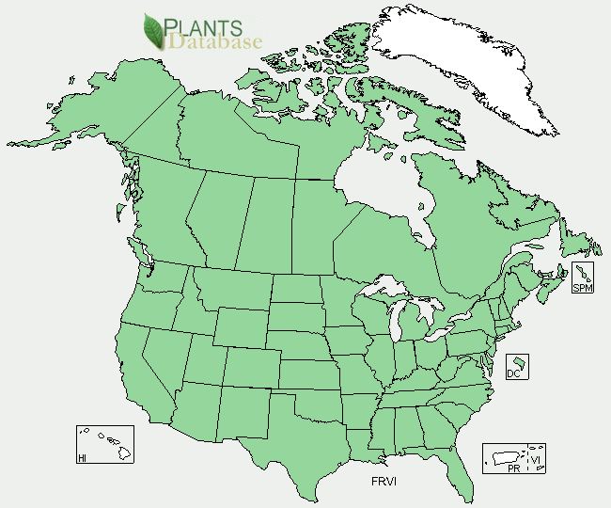
Locations of Fragaria virginiana by USDA Plants Database
Summary
In conclusion, the Rose family is extremely varied in its members. Morphology within the family differs in many ways, and reproduction is quite unique for certain species. They can be found on every continent except Antarctica, and they range from small herbs such as Fragaria virginiana to small and large woody forbs and trees such as Crataegus douglasii (Douglas Hawthorn) or Prunus serotina (Black Cherry Tree).

Footnotes
1 - Having leaflets arranged on either side of the stem, typically in pairs opposite each other
2 - Each of the parts of the calyx of a flower, enclosing the petals and typically green and leaf like
3 - A fruit containing much fleshy tissue besides that of the ripened ovary
4 - Plants that are part of the same system as the first or parent plant
5 - Bunches of leaves consisting of three leaves in a bunch
6 - The stalk by which a leaf is attached to a stem
7 - Plants that are part of the same system as the first or parent plant
Sources:
"Fragaria Virginiana." PLANTS Profile for Fragaria Virginiana. Ed. USDA. USDA, 26 May 2012. Web. 26 May 2012. <http://plants.usda.gov/java/profile?symbol=FRVI>.
Hilty, John. "Wild Strawberry (Fragaria Virginiana)." Wild Strawberry (Fragaria Virginiana). Web. 29 May 2012. <http://www.illinoiswildflowers.info/prairie/plantx/wld_strawberryx.htm>.
"ITIS Standard Report - Error." ITIS Standard Report - Error. U.S. Fish and Wildlife. Web. 29 May 2012. <http://www.itis.gov/servlet/SingleRpt/SingleRpt?search_topic=TSN>.
Johnson, Charles G. Broadpetal Strawberry- Fragaria Virginiana. Common Plants of the Inland Pacific Northwest. 1998. 237-38. Print.
Kershaw, Linda, Andy MacKinnon, and Jim Pojar. Plants of the Rocky Mountains. Auburn: Lone Pine, 1998. 148. Print.
"Polypodiophyta." Polypodiophyta. University of Wisconsin. Web. 29 May 2012. <http://botit.botany.wisc.edu/courses/systematics/Phyla/Pterophyta/Pterophyta.html>.
Wagner, Nancy. "How Do Wild Strawberry Plants Reproduce?" EHow. Demand Media, 18 Nov. 2010. Web. 29 May 2012. <http://www.ehow.com/facts_7521264_do-wild-strawberry-plants-reproduce.html>.

